About Us
Reach-Tech LED Lighting Co., Ltd (a member of Reach-Tech Group), is a professional LED light manufacturer and exporter in China. We are engaged in manufacturing the LED bulb, LED Spotlight, LED Tube, and LED Ceiling Light. Our products are widely used in commercial lighting, industrial lighting, civilian lighting, lighting project, courtyard, parks, buildings, hotels, guesthouses, indoor and outdoor decoration projects and so on.
We run our factory under ISO9001:2000 system, all the products have CE and RoHs certificates, some of them also have UL and EMC certificates.
Keep the customer and end user both satisfied with our products and services is our final destination.
Technology (右下脚的3排文字能帮忙处理掉嘛？)
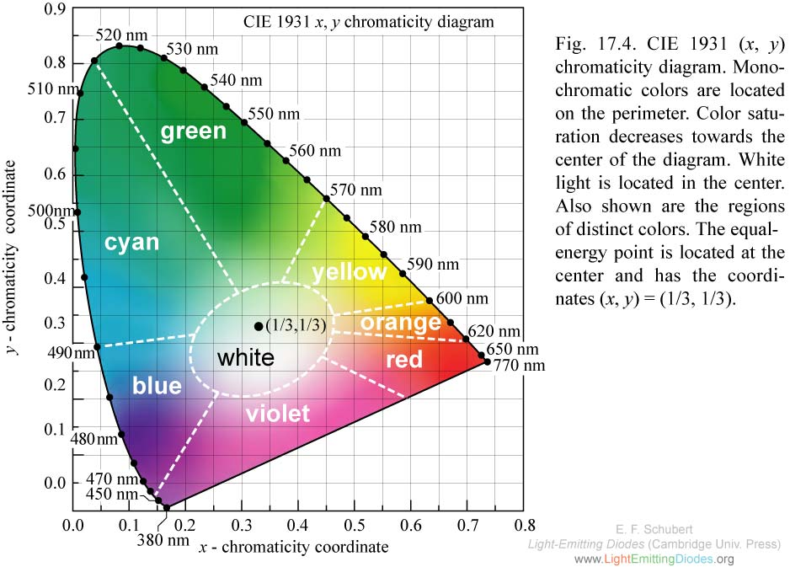
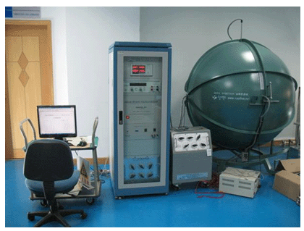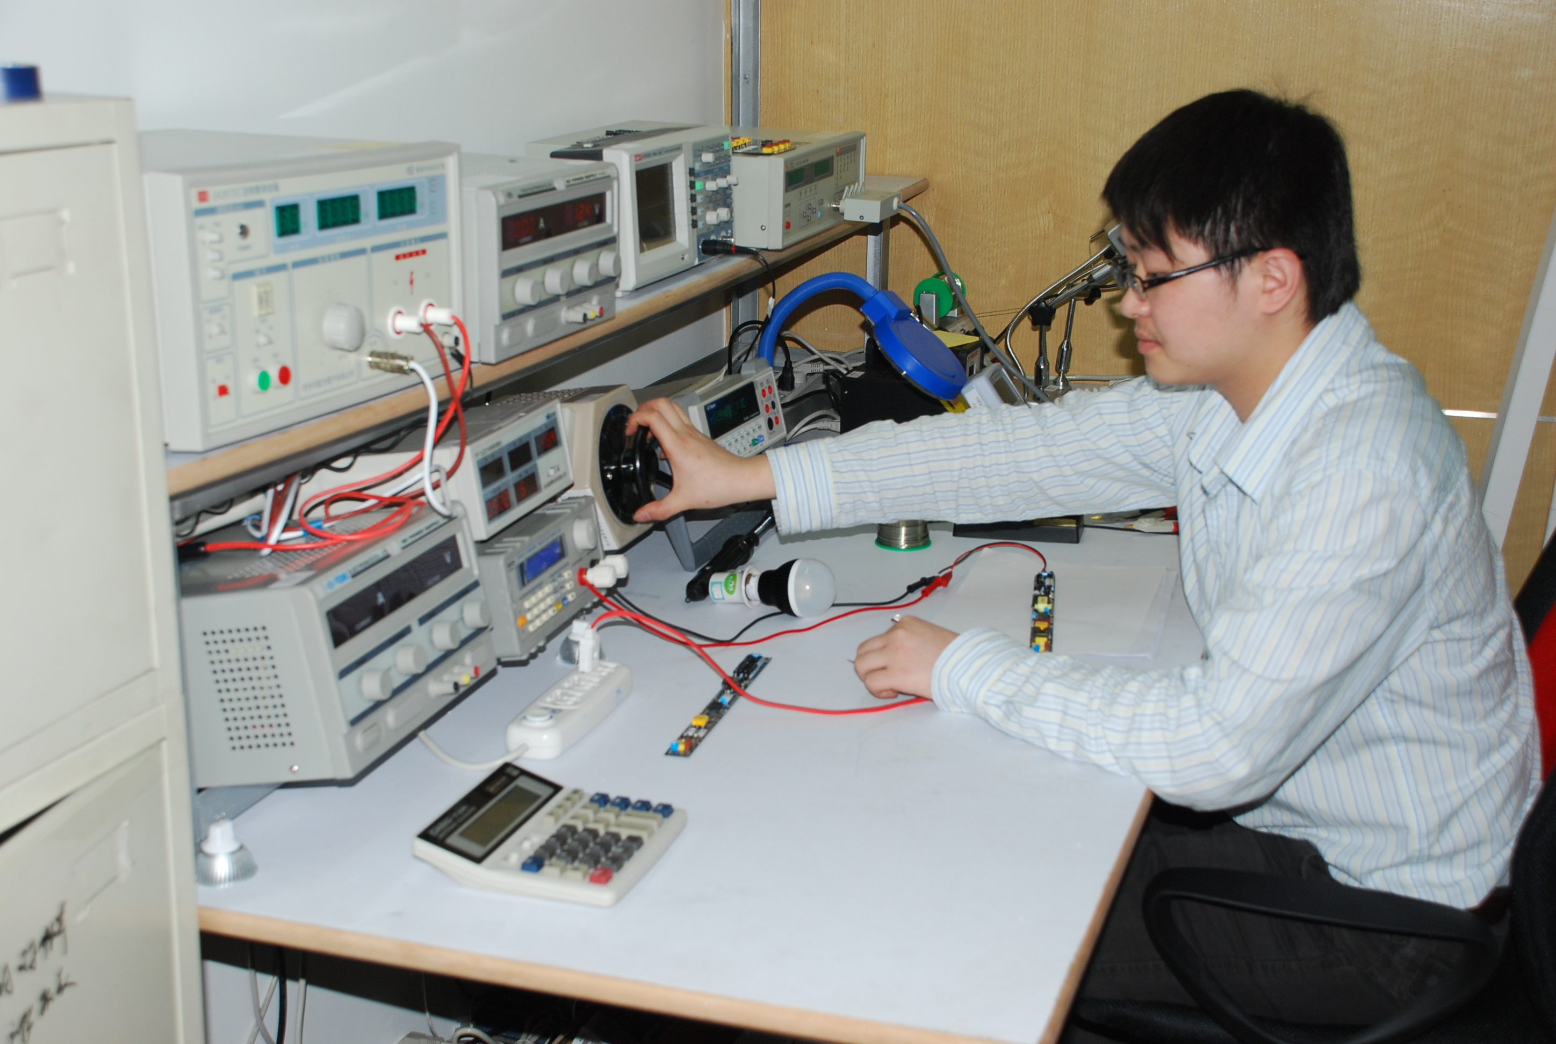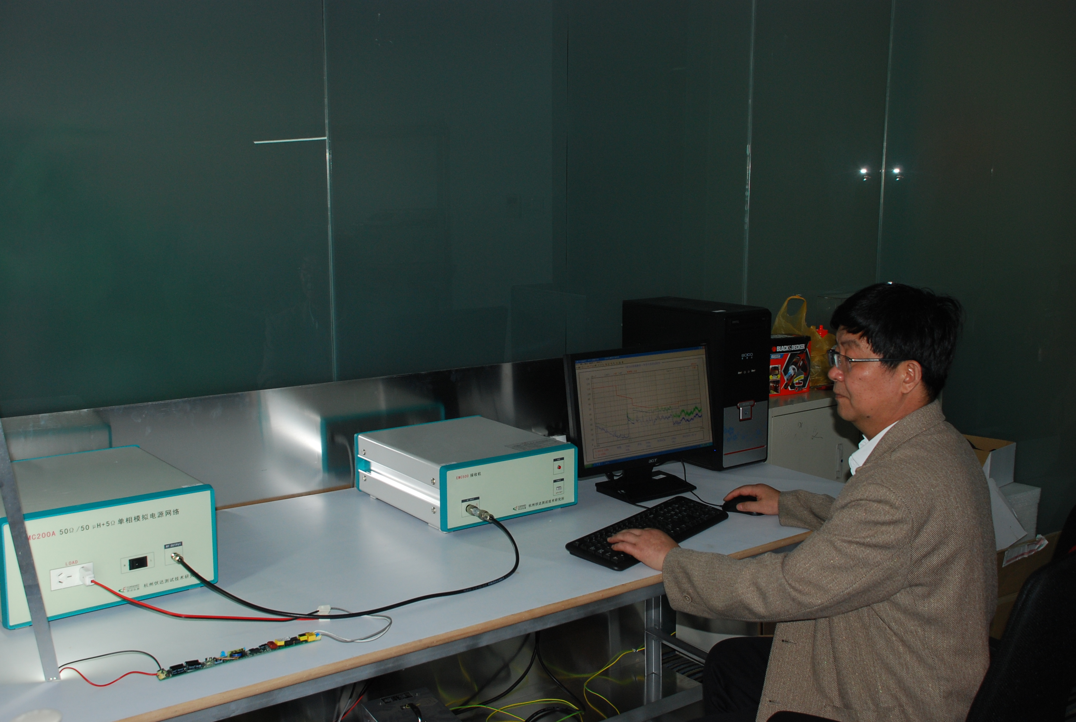

Service
OEM/ODM
We also offer OEM / ODM service to worldwide partners,
The goal of our OEM process is to help ensure the market success of your product. Therefore, our OEM relationship goes far beyond the typical OEM agreement that offers little support after the initial phase. The entire program is designed to help achieve the success of your product.
Product Development
The first key to market success is developing the correct product. During the initial planning phase, our project manager will help you select and successfully integrate the appropriate technology for your product.
Engineering Support
Our project manager can also provide engineering support to help with the design of your mold, development and manufacture of your product, including evaluating your designs, suggesting modifications, and testing prototypes of the product. We are working to meet the challenge by being assigned the tough projects and we commit to complete the assignment on a time definite basis.
Sales Related Support
Our OEM/ODM also helps you with the label, package, borch, manual and sales literature design, Which will help your products ready for your customers.
So you can be more than ready to penetrate the new market.
Quality
We are committed to excellence by researching the latest technological advances and continuously renewing and updating our product line. Therefore, we got most of the certificates which are necessary for the local market.

